Meet the Farmers
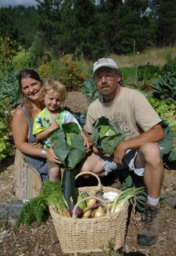
Carter Morris and Joni Steiner with their your sons Justice and Orion(not pictured)have been farming in the Purgatory Valley area for 10 years at an altitude of 8,000ft. They are the creators of Earth Mountain Education Farm and the Trinidad Community Garden.
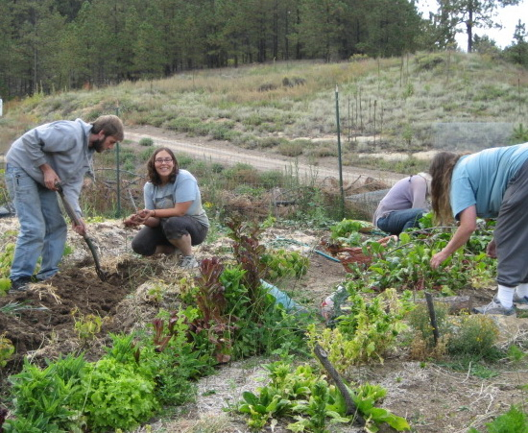
Work trade interns, volunteers from the community, and working CSA members help make the CSA possible. We appreciate you!
Other Programs offered through the CSA and Earth Mountain Education Farm
School Farm Program
Weekly, monthly, and seasonal visits to the farm for area schools. (Year-round)
Students will get a chance to get in the dirt and be hands-on in the garden and greenhouse!
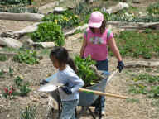
Internship Program
Become a part of a working CSA learning the ins and outs from practical organic gardening knowledge to aspects of business.
Residential Internship: March 1st-Nov. 1st (2 weeks-6 month stay) live in a tipi/practice sustainable living/ learn with others
Farm Tours Sundays (11am-4pm) (call ahead) Tour the farm, share in a homegrown meal, learn principles of sustainable living, and enjoy a fine day up on the mountain!
The Learning Farms CSA Cooperative

A cooperation of local farms working together to provide fresh, quality organic produce to the community.
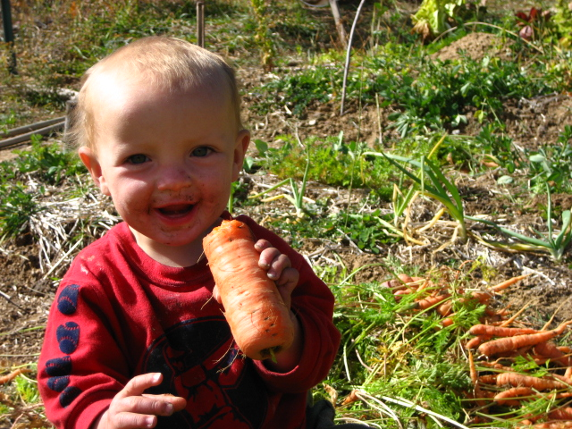
“We hunger for a true connection to what’s on our plates. We want to participate in a food system that is ecological, just, nourishing, and connected to community. Community Supported Agriculture (CSA) offers this and more.”
Jessica Prentice
author of Full Moon Feast
Earth Mountain Education Farm
(a501c-3 non-profit organization) 17613 County Rd. 31.9
Weston, CO 81091 (719) 680-0215 earthmountainfarm.@yahoo.com www.earthmountainfarm.org
What is CSA?
It is a farm in which the farmer and consumer (member) provide mutual support, and share in the benefits and risks of food production. Community Supported Agriculture (CSA) farms are usually small farms which practice sustainable farming methods and grow a variety of organic produce. It is direct marketing, meaning there is no middle man between the produce and the consumer allowing prices to stay affordable, and the quality of produce to be optimal and fresh.
You must be the change you wish to see in the world. Mahatma Ghandi
Benefits to the Community
- Allows for small farms to survive and flourish (challenging the global industrial food system)
- The high economic and environmental costs of transporting food is minimized(the average meal travels 1200 miles from the farm to your plate)
- Builds local sustainable economy and food security
- Allows people to be connected to their food, knowing who is growing it, participating, and know how it is grown
- Encourages us to eat seasonally
Memberships
Members pay an annual membership fee to cover anticipated costs of the farm operations. In return, members receive shares in the farms bounty each week throughout the growing season.
Working Memberships: if you are on a tight budget or just like to work outdoors, consider a working membership. Volunteer just 4 hrs./week and get a considerable discount. You’ll make some great friends while working towards a common goal.
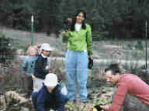
Share Prices
Full Share: feeds a family of 4
- Non-working $592 ($37/week)
- Working(4 hrs./week) $500
Half Share: Feeds a family of two and small children
- Non-working $352 ($22/week)
- Working $300
Single Share: Feeds one/two person
- Non-working $192 ($12/week)
- Working $160
Harvest Schedule
approx. 16 weeks of produce
Produce | June | July | Aug | Sept | Oct
Green beans |  |  | x | x
beets |  | x | x | x
broccoli |  |  | x | x | x
cabbage |  |  |  | x | x
carrots |  |  | x | x | x
cauliflower |  |  |  | x | x
celery |  | x | x | x
swiss chard | x | x | x | x
garlic |  |  |  | x | x
herbs | x | x | x | x | x
lettuce | x | x | x | x | x
onions |  |  | x | x | x
peppers |  |  | x | x
potatoes |  |  | x | x | x
snow /snap peas | x | x |  |  | x
spinach | x | x | x | x | x
summer squash |  |  | x | x
tomatoes |  |  | x | x | x
winter squash |  |  |  | x | x
Harvest schedule subject to changes due to the nature of farming! As a member you will receive a mixed bag of delicious mountain grown produce each week as crops come into season. **Goat cheese and home-baked bread and eggs may be available upon pre-ordering at an additional cost.
“The only possible alternative to being either the oppressed or the oppressor is voluntary cooperation.” Enrico Malatesta

